# Creating API by importing from Swagger Specification

## Product Assets Service

1. In the Publisher Portal, click on APIs 🡪 Import API. In the dialog, enter values as shown below. For Swagger specification, provide the URL to the live Swagger API specification created in the earlier hands-on.

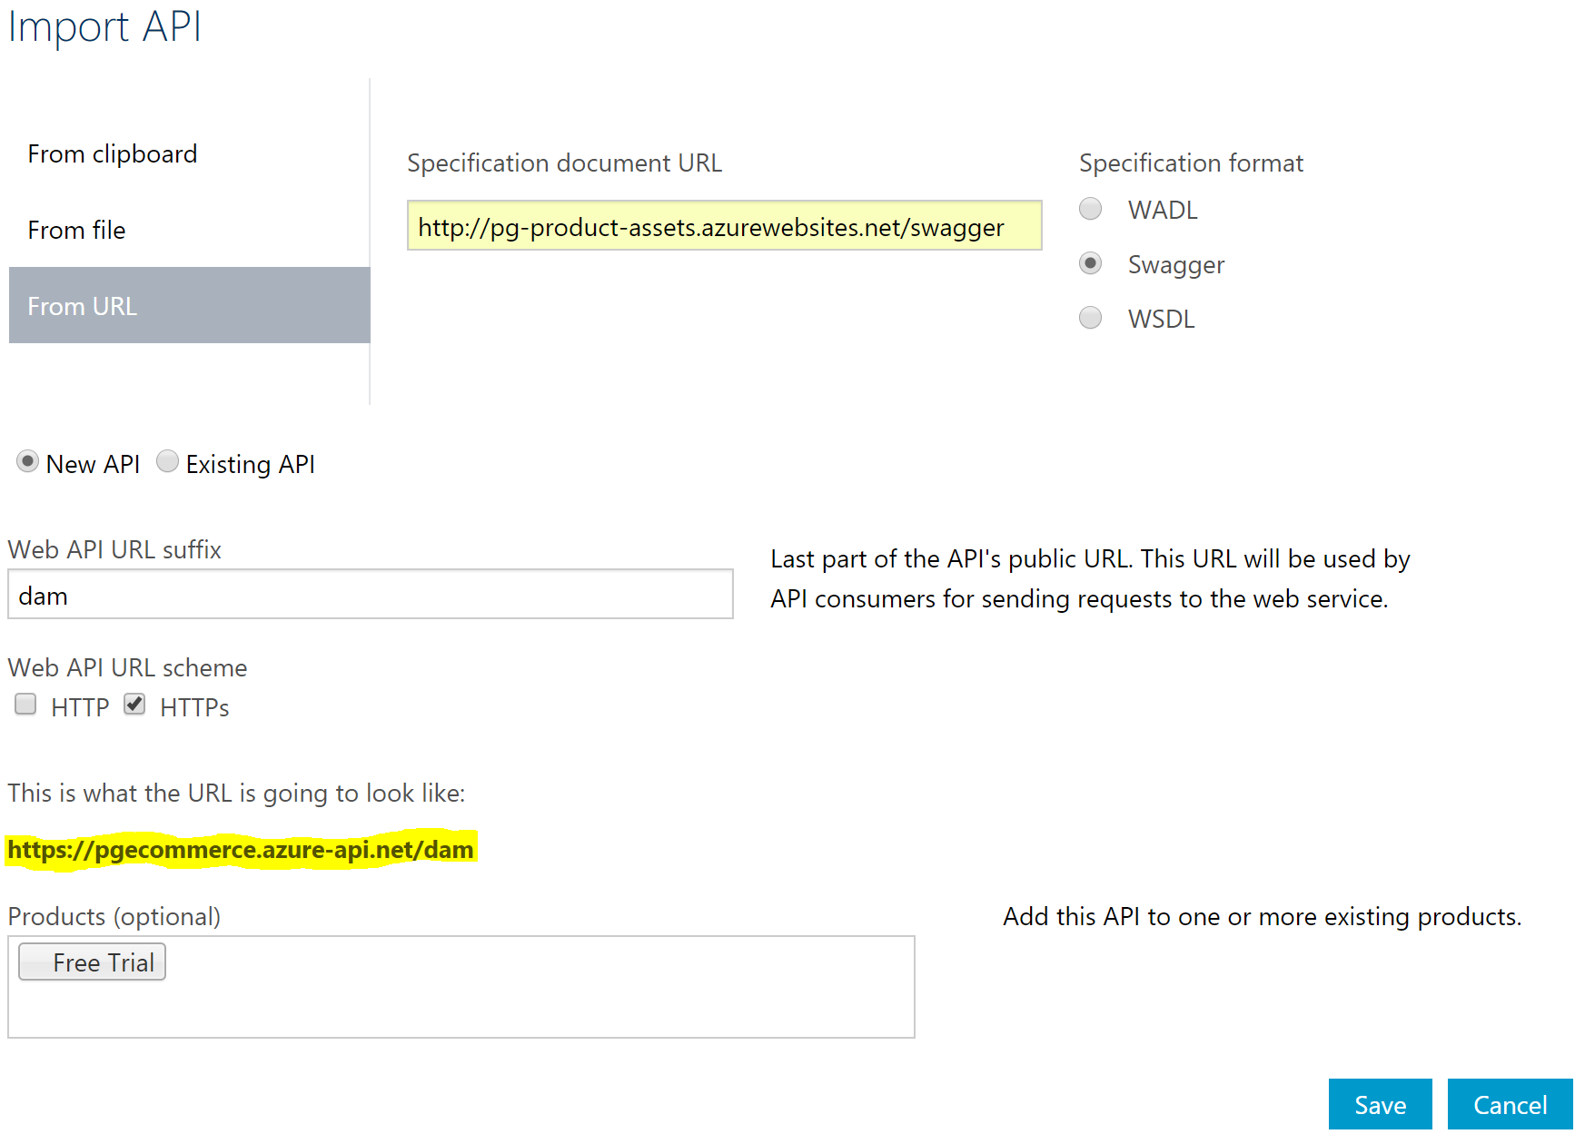

1. Once the API is created, explore the API configuration – Settings, Operations, Security and Products.

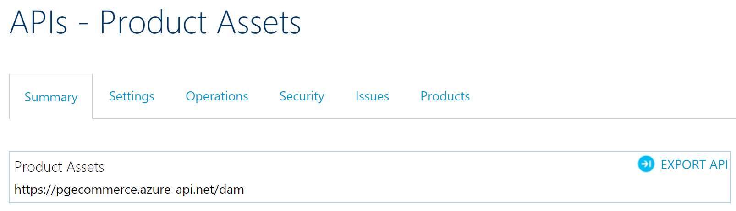

1. Verify that the API endpoints configured in Azure API Management works as expected:

<https://pgecommerce.azure-api.net/dam/assets>

<https://pgecommerce.azure-api.net/dam/assets/47400656109>

*Note 1: the internal / backend url is on HTTP, whereas the public url configured on API Gateway is on HTTPS.*

*Note 2: the internal / backend url in this demo is still available on the public internet, but it can be secured using various Azure security options (Network Security Groups, firewall, restricting access to only Azure API Management VIP, etc.) – but that is outside the scope of this training.*

## Product Master Service

1. Create Product Master service like Product Assets service by importing the Swagger specification. Configure the service with the following values: (need to fill after the service is hosted in Azure)

## Email Service

1. Create Email service like Product Assets service by importing the Swagger specification. Configure the service with the following values: (need to fill after the service is hosted in Azure – assuming that we will have Swagger spec created for this section; else will have to move it to next section, i.e., manually)

# Creating API Manually

## Order Service

1. In the Publisher Portal, click on APIs 🡪 Add API. In the dialog, enter values as shown below: (need to fill after the service is hosted in Azure)

## Inventory Service

1. In the Publisher Portal, click on APIs 🡪 Add API. In the dialog, enter values as shown below: (need to fill after the service is hosted in Azure)

# References

* Configuring APIs – <https://docs.microsoft.com/en-us/azure/api-management/api-management-howto-create-apis>
* Configuring API operations – <https://docs.microsoft.com/en-us/azure/api-management/api-management-howto-add-operations>